**UPDATED ANALYSIS ON 2D CNN ARCHITECTURE MODEL ON BRAIN TUMOR CLASSIFICATION**

1. **Activation Function ReLu:**

|  |  |
| --- | --- |
| Kernel Size | 3x3 |
| No. Of Kernels | 1st Layer: 32 Kernels  2nd Layer: 64 Kernels  3rd Layer: 128 Kernels |
| Activation Function | ReLu |
| Dropout Layers | No Dropout Layers |
| FCs Layer | 1 Fully Connect Layers  Dense (128, activation = ReLU) |
| Regularization | No regularization |
| Max Pooling | First Max Pooling: (2x2)  Second Max Pooling: (2x2)  Third Max Pooling: (2x2) |
| No. of Control Layers | No Specific Control Layers |

* Result and Observation:

| **Epoch** | **Training Accuracy** | **Training Loss** | **Validation Accuracy** | **Validation Loss** |
| --- | --- | --- | --- | --- |
| 1 | 0.4225 | 1.3662 | 0.6112 | 1.0262 |
| 2 | 0.6775 | 0.8042 | 0.7070 | 0.7986 |
| 3 | 0.7149 | 0.7031 | 0.6889 | 0.7984 |
| 4 | 0.7377 | 0.6444 | 0.6426 | 1.0037 |
| 5 | 0.7562 | 0.6068 | 0.6905 | 0.8054 |
| 6 | 0.7720 | 0.5701 | 0.7408 | 0.6797 |
| 7 | 0.7719 | 0.5706 | 0.7172 | 0.7343 |
| 8 | 0.8057 | 0.4955 | 0.7926 | 0.5415 |
| 9 | 0.7951 | 0.5069 | 0.7863 | 0.5387 |
| 10 | 0.8153 | 0.4807 | 0.8115 | 0.4872 |
| 11 | 0.8238 | 0.4384 | 0.8146 | 0.4930 |
| 12 | 0.8254 | 0.4424 | 0.7636 | 0.6087 |
| 13 | 0.8325 | 0.4185 | 0.8335 | 0.4375 |
| 14 | 0.8465 | 0.4092 | 0.7510 | 0.6673 |
| 15 | 0.8561 | 0.3853 | 0.8060 | 0.5424 |
| 16 | 0.8477 | 0.3920 | 0.8421 | 0.4248 |
| 17 | 0.8565 | 0.3835 | 0.8358 | 0.4533 |
| 18 | 0.8680 | 0.3441 | 0.8335 | 0.4332 |
| 19 | 0.8754 | 0.3395 | 0.8578 | 0.3902 |
| 20 | 0.8800 | 0.3241 | 0.8319 | 0.4698 |
| 21 | 0.8703 | 0.3260 | 0.8405 | 0.4436 |
| 22 | 0.8796 | 0.3247 | 0.8350 | 0.4424 |
| 23 | 0.8868 | 0.3045 | 0.8743 | 0.3341 |
| 24 | 0.8760 | 0.3239 | 0.8625 | 0.3754 |
| 25 | 0.8906 | 0.2958 | 0.8547 | 0.3815 |
| 26 | 0.8827 | 0.2967 | 0.8775 | 0.3425 |
| 27 | 0.8936 | 0.2792 | 0.8500 | 0.3653 |
| 28 | 0.8917 | 0.2967 | 0.8735 | 0.3492 |
| 29 | 0.9019 | 0.2669 | 0.8523 | 0.3816 |
| 30 | 0.8974 | 0.2810 | 0.8798 | 0.3021 |
| 31 | 0.9139 | 0.2275 | 0.8798 | 0.3108 |
| 32 | 0.8999 | 0.2506 | 0.8767 | 0.3195 |
| 33 | 0.8976 | 0.2703 | 0.8625 | 0.3687 |
| 34 | 0.9082 | 0.2552 | 0.8963 | 0.2886 |
| 35 | 0.9044 | 0.2461 | 0.8877 | 0.3259 |
| 36 | 0.8982 | 0.2629 | 0.8767 | 0.3205 |
| 37 | 0.9072 | 0.2346 | 0.9042 | 0.2462 |
| 38 | 0.9111 | 0.2333 | 0.8767 | 0.3396 |
| 39 | 0.9147 | 0.2329 | 0.8885 | 0.3044 |
| 40 | 0.9225 | 0.2071 | 0.8979 | 0.2655 |
| 41 | 0.9239 | 0.2042 | 0.8853 | 0.3029 |
| 42 | 0.9222 | 0.2098 | 0.8971 | 0.2731 |
| ***43*** | ***0.9255*** | ***0.1962*** | ***0.9159*** | ***0.2400*** |
| 44 | 0.9149 | 0.2280 | 0.8963 | 0.2859 |
| 45 | 0.9314 | 0.1852 | 0.8932 | 0.3050 |
| 46 | 0.9250 | 0.2039 | 0.8680 | 0.3879 |
| 47 | 0.9310 | 0.1891 | 0.9034 | 0.2654 |
| 48 | 0.9224 | 0.2107 | 0.9097 | 0.2420 |
| 49 | 0.9302 | 0.1820 | 0.9011 | 0.2966 |
| 50 | 0.9308 | 0.1764 | 0.9113 | 0.2784 |

Test Accuracy: 0.9159

Test Loss: 0.2400

* Graph:

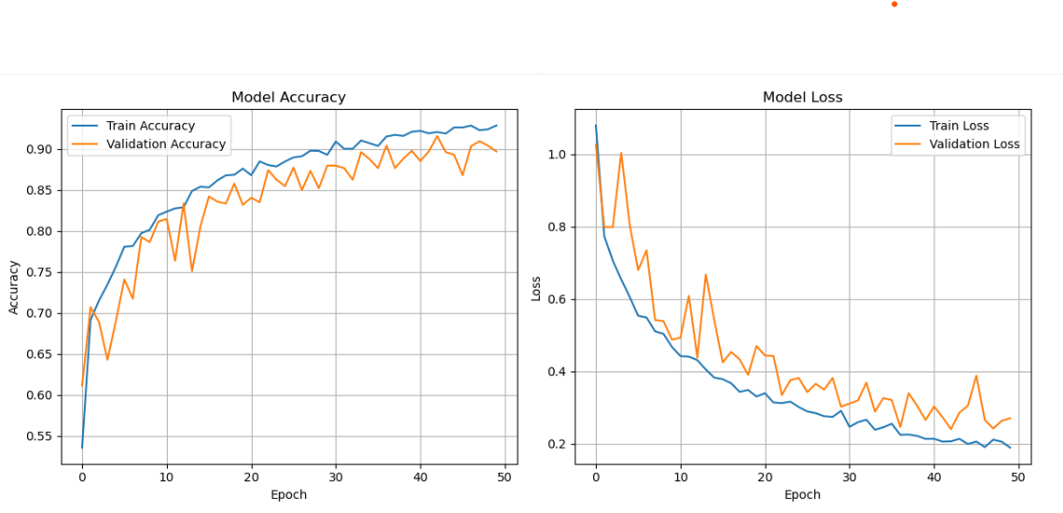

1. **Activation Function Sigmoid:**

|  |  |
| --- | --- |
| Kernel Size | 3x3 |
| No. Of Kernels | 1st Layer: 32 Kernels  2nd Layer: 64 Kernels  3rd Layer: 128 Kernels |
| Activation Function | Sigmoid |
| Dropout Layers | No Dropout Layers |
| FCs Layer | 1 Fully Connect Layers  Dense (128, activation = ReLU) |
| Regularization | No regularization |
| Max Pooling | First Max Pooling: (2x2)  Second Max Pooling: (2x2)  Third Max Pooling: (2x2) |
| No. of Control Layers | No Specific Control Layers |
|  |  |

* Result and Observation:

| **Epoch** | **Training Accuracy** | **Training Loss** | **Validation Accuracy** | **Validation Loss** |
| --- | --- | --- | --- | --- |
| 1 | 0.2812 | 1.3977 | 0.6826 | 0.8114 |
| 2 | 0.6838 | 0.7801 | 0.6858 | 0.7955 |
| 3 | 0.7228 | 0.6972 | 0.7628 | 0.6026 |
| 4 | 0.7499 | 0.6197 | 0.7211 | 0.7256 |
| 5 | 0.7611 | 0.5833 | 0.7573 | 0.6239 |
| 6 | 0.7808 | 0.5466 | 0.7659 | 0.6175 |
| 7 | 0.8134 | 0.4933 | 0.7062 | 0.7591 |
| 8 | 0.8057 | 0.4862 | 0.7753 | 0.5646 |
| 9 | 0.8262 | 0.4605 | 0.8130 | 0.4775 |
| 10 | 0.8068 | 0.4750 | 0.8020 | 0.4789 |
| 11 | 0.8412 | 0.3994 | 0.8170 | 0.4445 |
| 12 | 0.8289 | 0.4206 | 0.8201 | 0.4327 |
| 13 | 0.8527 | 0.3840 | 0.8107 | 0.4479 |
| 14 | 0.8454 | 0.3906 | 0.8052 | 0.4751 |
| 15 | 0.8574 | 0.3612 | 0.8350 | 0.3939 |
| 16 | 0.8683 | 0.3479 | 0.8099 | 0.4821 |
| 17 | 0.8638 | 0.3576 | 0.8476 | 0.3724 |
| 18 | 0.8770 | 0.3386 | 0.8013 | 0.5104 |
| 19 | 0.8622 | 0.3397 | 0.8523 | 0.3745 |
| 20 | 0.8701 | 0.3163 | 0.8335 | 0.3959 |
| 21 | 0.8752 | 0.3276 | 0.8515 | 0.3808 |
| 22 | 0.8729 | 0.3282 | 0.8437 | 0.3945 |
| 23 | 0.8769 | 0.3296 | 0.8295 | 0.4259 |
| 24 | 0.8898 | 0.2830 | 0.8295 | 0.4224 |
| 25 | 0.8868 | 0.2880 | 0.8720 | 0.3247 |
| 26 | 0.8917 | 0.2857 | 0.8539 | 0.3533 |
| 27 | 0.9056 | 0.2574 | 0.8657 | 0.3258 |
| 28 | 0.8967 | 0.2777 | 0.8720 | 0.3135 |
| 29 | 0.8958 | 0.2679 | 0.8602 | 0.3532 |
| 30 | 0.9029 | 0.2372 | 0.8908 | 0.2691 |
| 31 | 0.9100 | 0.2355 | 0.8641 | 0.3341 |
| 32 | 0.9081 | 0.2537 | 0.8704 | 0.3224 |
| 33 | 0.9093 | 0.2376 | 0.8947 | 0.2844 |
| 34 | 0.9152 | 0.2200 | 0.8822 | 0.3207 |
| 35 | 0.9137 | 0.2378 | 0.8814 | 0.3000 |
| 36 | 0.9195 | 0.2118 | 0.8837 | 0.2761 |
| 37 | 0.9213 | 0.2131 | 0.8932 | 0.2693 |
| 38 | 0.9152 | 0.2117 | 0.9042 | 0.2485 |
| 39 | 0.9155 | 0.2218 | 0.9175 | 0.2109 |
| 40 | 0.9260 | 0.2038 | 0.9018 | 0.2486 |
| 41 | 0.9226 | 0.2021 | 0.9183 | 0.2026 |
| 42 | 0.9370 | 0.1816 | 0.9049 | 0.2449 |
| 43 | 0.9225 | 0.1954 | 0.9112 | 0.2185 |
| 44 | 0.9308 | 0.1860 | 0.9112 | 0.2155 |
| 45 | 0.9327 | 0.1818 | 0.9144 | 0.2100 |
| 46 | 0.9408 | 0.1595 | 0.8413 | 0.4423 |
| 47 | 0.9310 | 0.1895 | 0.9230 | 0.1940 |
| 48 | 0.9283 | 0.1834 | 0.9293 | 0.1792 |
| 49 | 0.9450 | 0.1524 | 0.9073 | 0.2441 |
| ***50*** | ***0.9384*** | ***0.1675*** | ***0.9379*** | ***0.1733*** |

Test Accuracy: 0.9379

Test Loss: 0.1733

* Graph:

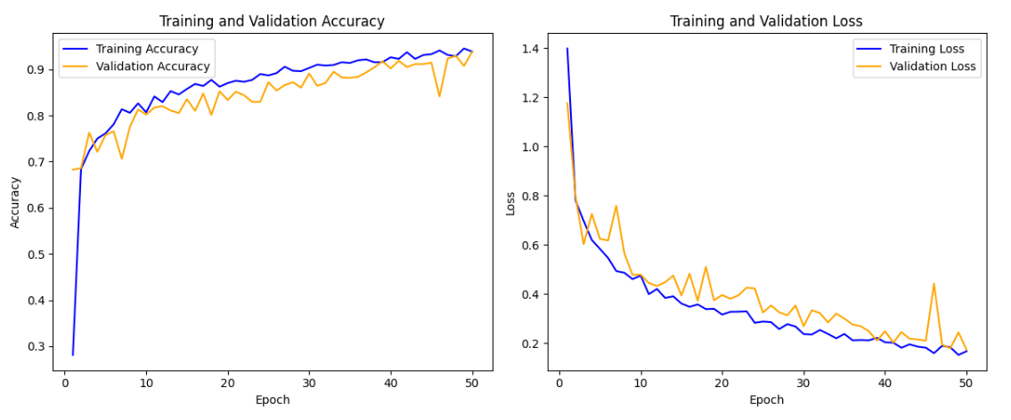

1. **Activation Function Sigmoid with Regularization:**

|  |  |
| --- | --- |
| Kernel Size | 3x3 |
| No. Of Kernels | 1st Layer: 32 Kernels  2nd Layer: 64 Kernels  3rd Layer: 128 Kernels |
| Activation Function | Sigmoid |
| Dropout Layers | No Dropout Layers |
| FCs Layer | 1 Fully Connect Layers  Dense (128, activation = ReLU) |
| Regularization | Elastic L1 and L2 Regularization |
| Max Pooling | First Max Pooling: (2x2)  Second Max Pooling: (2x2)  Third Max Pooling: (2x2) |
| No. of Control Layers | No Specific Control Layers |

* Result and Observation:

| **Epoch** | **Training Accuracy** | **Training Loss** | **Validation Accuracy** | **Validation Loss** |
| --- | --- | --- | --- | --- |
| 1 | 0.2812 | 6.2118 | 0.3936 | 1.7354 |
| 2 | 0.6300 | 1.1895 | 0.7031 | 1.1102 |
| 3 | 0.6792 | 1.0956 | 0.6489 | 1.1231 |
| 4 | 0.7175 | 1.0211 | 0.6127 | 1.2063 |
| 5 | 0.7339 | 0.9856 | 0.7164 | 1.0420 |
| 6 | 0.7371 | 0.9684 | 0.6591 | 1.1614 |
| 7 | 0.7357 | 0.9663 | 0.6379 | 1.3315 |
| 8 | 0.7485 | 0.9235 | 0.7361 | 0.9674 |
| 9 | 0.7429 | 0.9390 | 0.6968 | 1.1082 |
| 10 | 0.7530 | 0.9294 | 0.6190 | 1.2719 |
| 11 | 0.7609 | 0.8956 | 0.7070 | 1.0394 |
| 12 | 0.7674 | 0.9077 | 0.7392 | 1.0118 |
| 13 | 0.7790 | 0.8737 | 0.7211 | 1.0149 |
| 14 | 0.7832 | 0.8649 | 0.7636 | 0.8891 |
| 15 | 0.7867 | 0.8504 | 0.7376 | 0.9502 |
| 16 | 0.7624 | 0.8857 | 0.7463 | 0.9931 |
| 17 | 0.7779 | 0.8596 | 0.7463 | 0.9522 |
| 18 | 0.7975 | 0.8205 | 0.7706 | 0.8496 |
| 19 | 0.7869 | 0.8296 | 0.7431 | 0.9241 |
| 20 | 0.7986 | 0.8196 | 0.7447 | 0.9073 |
| 21 | 0.8114 | 0.7987 | 0.7455 | 0.9100 |
| 22 | 0.7953 | 0.8071 | 0.7714 | 0.8372 |
| 23 | 0.7981 | 0.8019 | 0.7651 | 0.8921 |
| 24 | 0.7902 | 0.8133 | 0.7793 | 0.8618 |
| 25 | 0.8150 | 0.7589 | 0.7620 | 0.9293 |
| 26 | 0.8121 | 0.7866 | 0.7675 | 0.8565 |
| 27 | 0.8025 | 0.7903 | 0.7502 | 0.9239 |
| 28 | 0.8188 | 0.7739 | 0.7863 | 0.8219 |
| 29 | 0.8154 | 0.7618 | 0.7604 | 0.8490 |
| 30 | 0.8213 | 0.7446 | 0.7636 | 0.9165 |
| 31 | 0.8194 | 0.7707 | 0.7855 | 0.7994 |
| 32 | 0.8352 | 0.7309 | 0.7903 | 0.8399 |
| 33 | 0.8177 | 0.7482 | 0.8099 | 0.7980 |
| 34 | 0.8388 | 0.7151 | 0.7793 | 0.8688 |
| 35 | 0.8318 | 0.7372 | 0.8272 | 0.7598 |
| 36 | 0.8362 | 0.7403 | 0.7910 | 0.8065 |
| 37 | 0.8566 | 0.6989 | 0.8225 | 0.7492 |
| 38 | 0.8262 | 0.7553 | 0.8060 | 0.7839 |
| 39 | 0.8502 | 0.6923 | 0.7934 | 0.8336 |
| 40 | 0.8614 | 0.6721 | 0.8248 | 0.7656 |
| 41 | 0.8520 | 0.7045 | 0.8185 | 0.7974 |
| 42 | 0.8493 | 0.6935 | 0.8052 | 0.8234 |
| 43 | 0.8493 | 0.6884 | 0.8162 | 0.7606 |
| 44 | 0.8539 | 0.6868 | 0.8288 | 0.7603 |
| 45 | 0.8498 | 0.6824 | 0.8311 | 0.7855 |
| 46 | 0.8548 | 0.6765 | 0.8193 | 0.8080 |
| 47 | 0.8643 | 0.6758 | 0.8178 | 0.7943 |
| 48 | 0.8610 | 0.6785 | 0.8382 | 0.7532 |
| 49 | 0.8547 | 0.6896 | 0.8342 | 0.7406 |
| 50 | 0.8558 | 0.6698 | 0.8460 | 0.7153 |
| 51 | 0.8577 | 0.6953 | 0.7690 | 0.9391 |
| 52 | 0.8714 | 0.6550 | 0.8107 | 0.8031 |
| 53 | 0.8638 | 0.6613 | 0.8437 | 0.7199 |
| 54 | 0.8814 | 0.6305 | 0.8397 | 0.7182 |
| 55 | 0.8737 | 0.6349 | 0.8382 | 0.7031 |
| 56 | 0.8785 | 0.6224 | 0.8437 | 0.7001 |
| 57 | 0.8787 | 0.6238 | 0.8460 | 0.7339 |
| 58 | 0.8716 | 0.6509 | 0.8374 | 0.7039 |
| 59 | 0.8759 | 0.6173 | 0.8280 | 0.7326 |
| 60 | 0.8802 | 0.6146 | 0.8515 | 0.6818 |
| 61 | 0.8799 | 0.6132 | 0.8342 | 0.7492 |
| 62 | 0.8777 | 0.6235 | 0.8445 | 0.7254 |
| 63 | 0.8735 | 0.6388 | 0.8374 | 0.7015 |
| 64 | 0.8763 | 0.6368 | 0.8579 | 0.6650 |
| 65 | 0.8861 | 0.6137 | 0.8538 | 0.6963 |
| 66 | 0.8914 | 0.5958 | 0.8545 | 0.6786 |
| 67 | 0.8829 | 0.6175 | 0.8579 | 0.6974 |
| 68 | 0.8827 | 0.6090 | 0.8460 | 0.7061 |
| 69 | 0.8891 | 0.6032 | 0.8587 | 0.6878 |
| 70 | 0.8896 | 0.5868 | 0.8587 | 0.6836 |
| 71 | 0.8971 | 0.5696 | 0.8553 | 0.6732 |
| 72 | 0.8912 | 0.5862 | 0.8538 | 0.7030 |
| 73 | 0.9004 | 0.5660 | 0.8595 | 0.6760 |
| 74 | 0.8968 | 0.5702 | 0.8635 | 0.6599 |
| 75 | 0.8929 | 0.5773 | 0.8568 | 0.6733 |
| 76 | 0.8993 | 0.5616 | 0.8500 | 0.6990 |
| 77 | 0.8957 | 0.5661 | 0.8658 | 0.6527 |
| 78 | 0.8985 | 0.5610 | 0.8643 | 0.6557 |
| 79 | 0.8966 | 0.5747 | 0.8635 | 0.6634 |
| 80 | 0.9020 | 0.5592 | 0.8650 | 0.6538 |
| 81 | 0.9016 | 0.5550 | 0.8643 | 0.6503 |
| 82 | 0.8960 | 0.5726 | 0.8666 | 0.6566 |
| 83 | 0.9016 | 0.5516 | 0.8619 | 0.6722 |
| 84 | 0.9023 | 0.5474 | 0.8635 | 0.6713 |
| 85 | 0.8991 | 0.5536 | 0.8576 | 0.6846 |
| 86 | 0.9034 | 0.5483 | 0.8619 | 0.6702 |
| 87 | 0.9009 | 0.5530 | 0.8627 | 0.6659 |
| 88 | 0.9004 | 0.5501 | 0.8635 | 0.6667 |
| 89 | 0.9018 | 0.5546 | 0.8658 | 0.6511 |
| 90 | 0.9030 | 0.5469 | 0.8627 | 0.6605 |
| 91 | 0.9071 | 0.5410 | 0.8673 | 0.6442 |
| 92 | 0.9054 | 0.5367 | 0.8643 | 0.6594 |
| 93 | 0.9059 | 0.5350 | 0.8689 | 0.6374 |
| 94 | 0.9036 | 0.5420 | 0.8595 | 0.6706 |
| 95 | 0.9048 | 0.5371 | 0.8643 | 0.6584 |
| 96 | 0.9041 | 0.5346 | 0.8603 | 0.6668 |
| 97 | 0.9064 | 0.5324 | 0.8627 | 0.6635 |
| ***98*** | ***0.9059*** | ***0.5344*** | ***0.8704*** | ***0.6455*** |
| 99 | 0.9062 | 0.5285 | 0.8673 | 0.6484 |
| 100 | 0.9096 | 0.5233 | 0.8689 | 0.6415 |

Test Accuracy: 0.8704

Test Loss: 0.6455

* Graph:

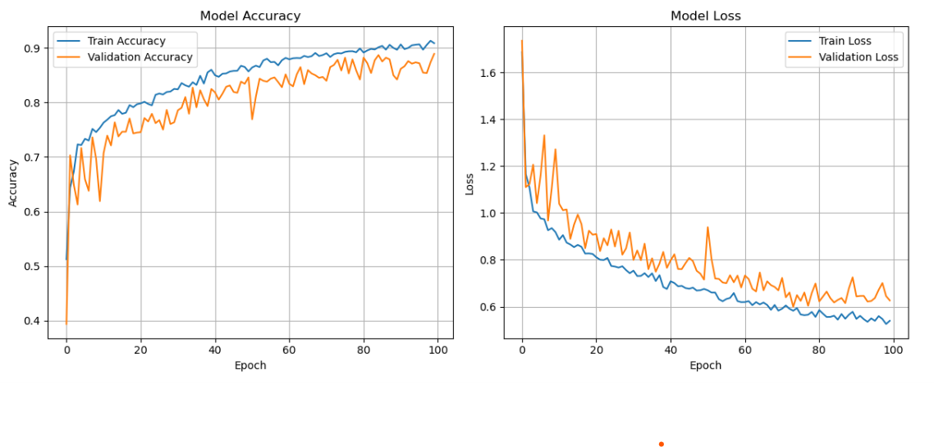

1. **Activation Function TanH:**

|  |  |
| --- | --- |
| Kernel Size | 3x3 |
| No. Of Kernels | 1st Layer: 32 Kernels  2nd Layer: 64 Kernels  3rd Layer: 128 Kernels |
| Activation Function | tanH |
| Dropout Layers | No Dropout Layers |
| FCs Layer | 1 Fully Connect Layers  Dense (128, activation = ReLU) |
| Regularization | No Regularization |
| Max Pooling | First Max Pooling: (2x2)  Second Max Pooling: (2x2)  Third Max Pooling: (2x2) |
| No. of Control Layers | No Specific Control Layers |

* Result and Observation:

| **Epoch** | **Accuracy** | **Loss** | **Validation Accuracy** | **Validation Loss** |
| --- | --- | --- | --- | --- |
| 1 | 0.4516 | 1.3979 | 0.6080 | 1.0818 |
| 2 | 0.6718 | 0.7967 | 0.6984 | 0.7409 |
| 3 | 0.7223 | 0.7057 | 0.7117 | 0.7806 |
| 4 | 0.7212 | 0.6950 | 0.7510 | 0.6356 |
| 5 | 0.7582 | 0.5858 | 0.7565 | 0.6158 |
| 6 | 0.7652 | 0.5894 | 0.7353 | 0.6331 |
| 7 | 0.7918 | 0.5238 | 0.7698 | 0.5340 |
| 8 | 0.7989 | 0.5075 | 0.7800 | 0.5279 |
| 9 | 0.8186 | 0.4796 | 0.7903 | 0.4725 |
| 10 | 0.8034 | 0.4886 | 0.7667 | 0.6139 |
| 11 | 0.8196 | 0.4719 | 0.7690 | 0.5336 |
| 12 | 0.8226 | 0.4524 | 0.7832 | 0.5398 |
| 13 | 0.8229 | 0.4516 | 0.7895 | 0.4965 |
| 14 | 0.8362 | 0.4319 | 0.7965 | 0.4668 |
| 15 | 0.8368 | 0.4092 | 0.8178 | 0.4504 |
| 16 | 0.8401 | 0.4097 | 0.8075 | 0.4335 |
| 17 | 0.8532 | 0.3763 | 0.8397 | 0.3944 |
| 18 | 0.8618 | 0.3552 | 0.7714 | 0.5948 |
| 19 | 0.8427 | 0.3958 | 0.8382 | 0.3834 |
| 20 | 0.8659 | 0.3441 | 0.8327 | 0.4378 |
| 21 | 0.8705 | 0.3466 | 0.8570 | 0.3523 |
| 22 | 0.8682 | 0.3539 | 0.8397 | 0.3900 |
| 23 | 0.8826 | 0.3124 | 0.8665 | 0.3390 |
| 24 | 0.8822 | 0.3106 | 0.8531 | 0.3563 |
| 25 | 0.8861 | 0.3069 | 0.8413 | 0.3721 |
| 26 | 0.8828 | 0.3100 | 0.8036 | 0.4903 |
| 27 | 0.8805 | 0.3151 | 0.8625 | 0.3352 |
| 28 | 0.8964 | 0.2779 | 0.8892 | 0.2968 |
| 29 | 0.9032 | 0.2693 | 0.8429 | 0.4343 |
| 30 | 0.8970 | 0.2637 | 0.8861 | 0.2917 |
| 31 | 0.9040 | 0.2641 | 0.8625 | 0.3724 |
| 32 | 0.8986 | 0.2670 | 0.8892 | 0.2968 |
| 33 | 0.9090 | 0.2436 | 0.8492 | 0.3961 |
| 34 | 0.9049 | 0.2479 | 0.8515 | 0.4151 |
| 35 | 0.9050 | 0.2363 | 0.8995 | 0.2583 |
| 36 | 0.9089 | 0.2382 | 0.8672 | 0.3091 |
| 37 | 0.9113 | 0.2337 | 0.8507 | 0.3667 |
| 38 | 0.9281 | 0.2124 | 0.8798 | 0.2997 |
| 39 | 0.9130 | 0.2293 | 0.8822 | 0.2789 |
| 40 | 0.9164 | 0.2405 | 0.8916 | 0.2981 |
| 41 | 0.9196 | 0.2164 | 0.8885 | 0.2653 |
| 42 | 0.9215 | 0.2211 | 0.9057 | 0.2176 |
| 43 | 0.9133 | 0.2232 | 0.8798 | 0.2903 |
| 44 | 0.9160 | 0.2139 | 0.9057 | 0.2435 |
| ***45*** | ***0.9343*** | ***0.1834*** | ***0.9222*** | ***0.1881*** |
| 46 | 0.9342 | 0.1890 | 0.8908 | 0.2675 |
| 47 | 0.9281 | 0.1887 | 0.9042 | 0.2406 |
| 48 | 0.9264 | 0.1932 | 0.9183 | 0.1857 |
| 49 | 0.9291 | 0.1870 | 0.9207 | 0.1991 |
| 50 | 0.9271 | 0.1968 | 0.9002 | 0.2524 |

Test Accuracy: 0.9222

Test Loss:0.1881

* Graph:

